|  |  |
| --- | --- |
| **Semester: Spring 19-20** | **Group No: 5 Sec-B** |

**Project Information (Fill-up by Student)**

|  |
| --- |
| **Project Title: Shaat Gombuj Mosque**  **Introduction:** The Sat Gambuj Mosque ('Seven Domed Mosque') is near the northwestern outskirts of Dhaka in the Mohammadpur area.It is a fine example of the provincial Mughal style of architecture introduced in Bangladesh in the 17th century. The mosque's most notable features are its seven bulbous crowning the roof and covering the main prayer hall. Probably erected by Governor Shaista Khan, the monument stands in a romantic setting on a buttressed 15-foot-high bank overlooking an extensive flood plain. |

**Evaluation: (ID and Student Name fill-up by Student)**

|  |  |  |  |  |  |  |  |  |  |
| --- | --- | --- | --- | --- | --- | --- | --- | --- | --- |
| **ID** | **Student Name** | | **Sec** | **Code (15)** | **Viva (15)** | **Idea**  **(7.5)** | **Report**  **(7.5)** | **Demo**  **(5)** | **Total**  **(50)** |
| **17-34957-2** | **Alam, Shababul** | | **B** |  |  |  |  |  |  |
| **17-34941-2** | **Ayshik md wali mosnad** | | **B** |  |  |  |  |  |  |
| **18-37868-2** | **Ayan Roy** | | **B** |  |  |  |  |  |  |
| **18-37619-1** | **Hasnat Bin Sayed** | | **B** |  |  |  |  |  |  |
|  |  | |  |  |  |  |  |  |  |
| **Demo Submission Date:** | |  | | | | | | |  |
| **Final Submission Date:** | | **3/01/2021** | | | | | | |  |

**External Information**

|  |  |
| --- | --- |
| **Faculty Name** | **Signature** |
| **DR. MD. ABDULLAH - AL - JUBAIR** |  |
|  |  |

# Objective of project

As Sat Gambuj Mosque is the most beautiful historical architecture, we tried to show the scenario through our graphics project. We have added animation to make it more and more in our goal is to show the scenario of Sat Gambuj Mosque along with the beautiful natural view of Bangladesh.

# System Features

* Mosque View
* Mosque Street With Trees
* Animated River, Boat, Windmill
* Sky, Cloud, Sun, Star
* Movement of Sun and Cloud
* Keyboard interaction(speed control, pause, start)
* Use of Scaling loop
* Implement of Sound
* Multiple Display

# Software Used

* Code Blocks
* Some addition file including Wav

# Implementation

We have used different types of method to fulfill our project.

* Sky: we used GL_QUADS to draw the sky.
* Sun/Moon: We used GL_TRIANGLE_FAN to create circle with Moving Animation.
* Cloud: We used GL_TRIANGLE_FAN and Translation for cloud.
* Star: We used GL_POINTS to make stars.
* River: We used GL_POLYGON for river.
* Boat: We used GL_QUADS and Moving Animation for boat.
* Ground: We used GL_LINES and GL_POLYGON for ground.
* Mosque Base: We used GL_POLYGON and GL_QUADS.
* Road: We used GL_QUADS for road.
* Tree: We used GL_QUADS and GL_TRIANGLES for tree.
* Brush: We used GL_POLYGON and Translation for brush.
* Windmill: We used GL_TRIANGLES, Scaling, Rotation and Translation.
* Pillar: We used GL_QUADS, GL_ LINES and GL_TRIANGLE_FAN.

# Limitations

* Lacking of powerful device
* Sometimes it can take time to compile the project
* Key failure (day and night)

# Screenshots

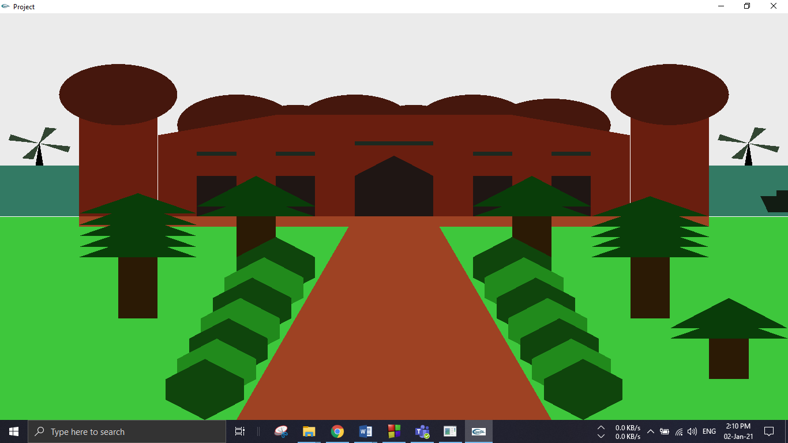

Morning View

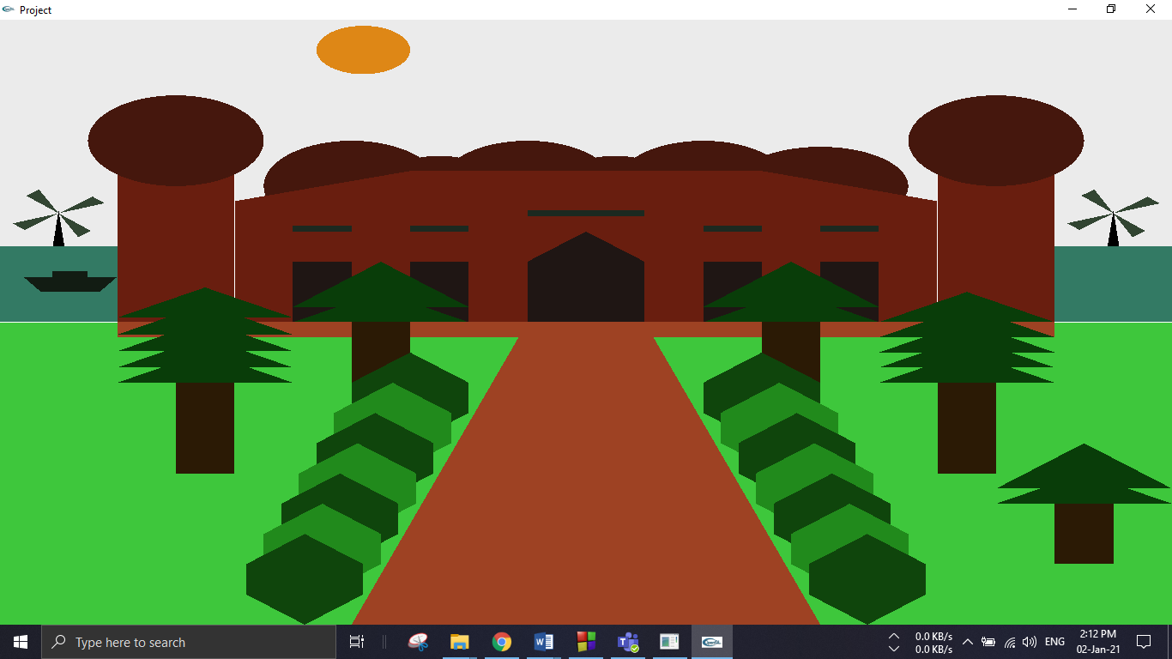

*After sun rises*

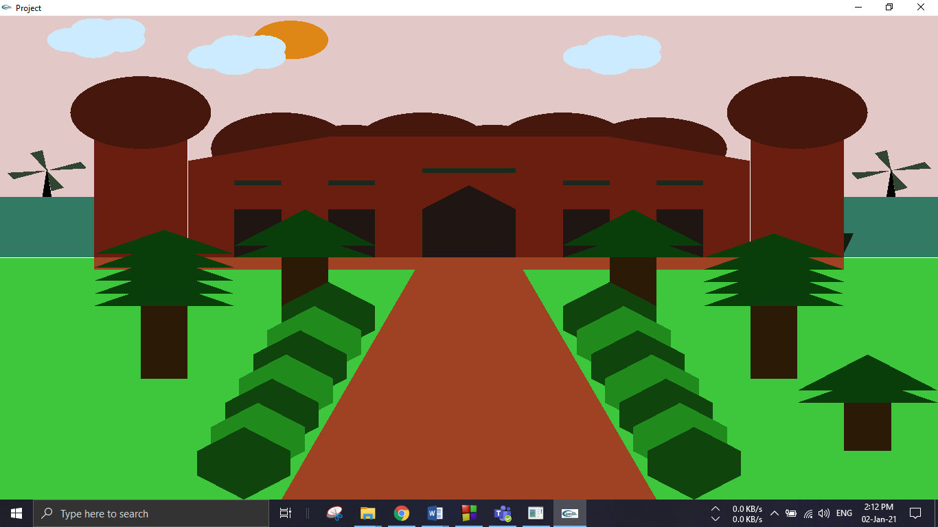 *Day view*

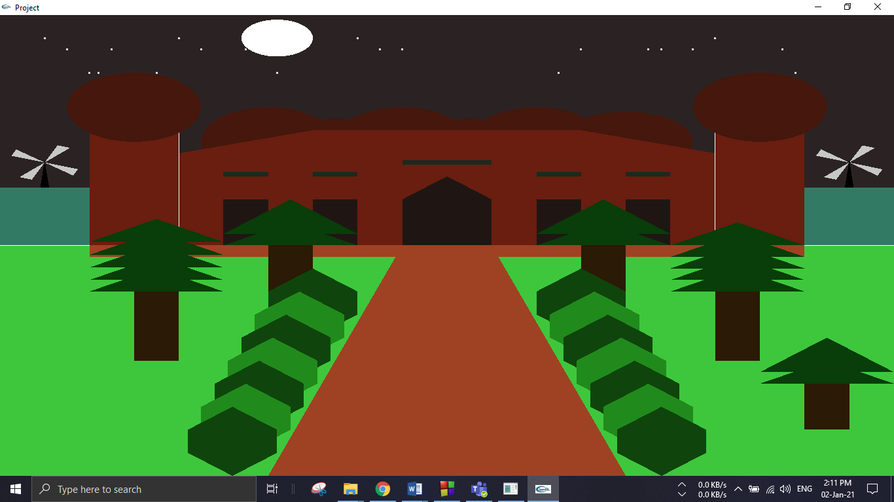

Night View